Coaching Handbook

2018
Table of Contents
Westshore Basketball Culture 3
Coaching Philosophy and Safety 4
The ABC’s of Athleticism 5
Specialization 6
Offensive Concepts 8
Defensive Concepts 10
Planning a Practice 11
U11 – FUNdamentals 12
U13 – Learn to Train 17
U15 – Train to Train 23
References 0
Additional Coaching Resources 0

Westshore Basketball Culture

Westshore Basketball coaches are committed to:
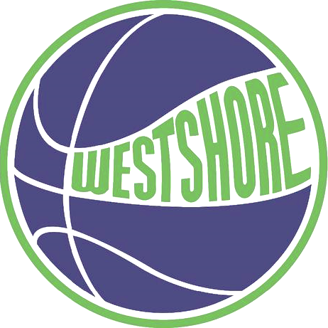
- Growth – what needs to be valued and praised is the process and effort that each player puts into the game. Challenges should be seen as an opportunity to learn, not as one to be judged upon or tested.
- Inclusion – there is a place for every child in the Westshore Basketball organization, and they are valued.
- Respect – respect for all the people involved in the game including but not limited to the players, coaches, and the refs, and respect for the facilities in which you play.
As an organization we strive to uphold these values above all else.

COACHING PHILOSOPHY AND SAFETY
Our philosophy as coaches at Westshore Basketball is that every player deserves to be the player that they want to be. We as coaches will not limit our players potential and hinder their enjoyment of the sport for our own personal success.
Coaching your own team can be easy, or it can be difficult. To make sure it is easy discipline will be required. A simple way to achieve the best chemistry between you and your players is to establish rules and guidelines within your team at the first practice such as “no talking during coach’s instruction” and “holding the basketball when coach is speaking”. A consequence for breaking these rules could be pushups or running. You must be consistent in enforcing your rules as the coach.
It must be understood that the safety of each athlete from physical and emotional harm is paramount to the Westshore Basketball culture, as well as the freedom of respectful expression within the program. These concepts should be the chief concern as coaches in our organization.
Understanding the rules of basketball are essential to ensuring the safety of your team. Rules are created and upheld for the safety of the players, and fouls are called to make sure the game is played safely. This means that there is no such thing as a “good foul,” and using this term and encouraging these types of plays is not being respectful of the rules created to govern the game.

THE ABC’S OF ATHLETICISM
The fundamental movement skills which cover the first stage of the Teaching Progressions can be thought of the ABC’s of athleticism, which include:
- Agility
- Balance
- Coordination and Speed
The ABC’s of athleticism are critical to the future success of your athletes and will provide them with the necessary foundation to build their skills on as they grow. It is important to understand that every child is an athlete and needs proper grounding in movement in order to develop an appreciation for physical activity, and that a poorly developed movement skill will greatly affect the development of the basketball skill.

TEACHING THE FUNDAMENTAL MOVEMENT SKILLS
At earlier ages such as Rain and U11, teaching movement skills can be done primarily with fun games and should be the focus of your practice. If a basketball is included in the games it is uncomplicated, and the technique of dribbling, shooting, or passing should be secondary to the proper movement of the athletes – especially with the Rain programs. As the athletes’ progress from Rain to U11 and U13 and so on, the fundamental movements are refined, and can be focused on during the dynamic warmup portion of the practice.

SPECIALIZATION
There are two parts to specialization in basketball:
- Sport Specialization
- Positional Specialization

SPORT SPECIALIZATION
Sport specialization is the time when an athlete decides to pursue excellence in only one sport. Basketball is a late specialization sport, meaning that early specialization (the idea that only playing basketball from a young age in the hopes that it will give your athlete a developmental advantage equalling greater success) is not advantageous and can be detrimental to the athlete. Early specialization can lead to:
- Early burnout
- Increased risk of injuries
- Lack of basic fundamental movement skills
Multilateral development (the participation of the athletes in multiple sports) lays the groundwork for later periods of training when specialization becomes a greater focus of the training plan. If properly implemented, the multilateral training phase will allow the athlete to develop the physiological and psychological basis needed to maximize performance later in his career.

POSITIONAL SPECIALIZATION
Just like how early specialization in basketball has negative consequences on the overall development of the athlete, so does positional specialization of the players. Every player deserves an opportunity to develop all the skills of basketball, so it is crucial that your players learn how to be global basketball players instead of specialized ones. A global basketball player is one who is well rounded in all the movements and skills involved in basketball.
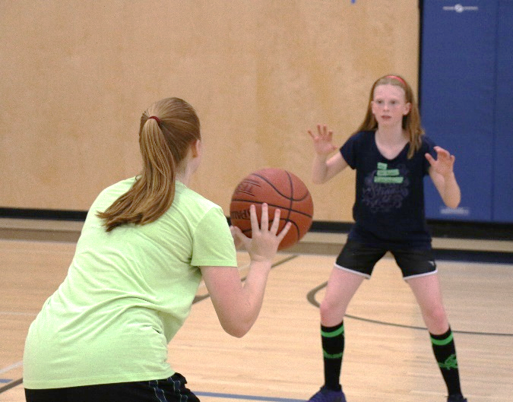
THINK!
How could specializing your players in a position affect their overall development in basketball? How would it affect their future participation in basketball?

THINK!

How could early sport specialization in basketball affect the players durability and involvement in the game?

Coaches need to avoid labeling players as “post-players” or “point guards.” Our goal is to build global players capable of all the skills required to excel in basketball.

OFFENSIVE CONCEPTS
The athletes understanding of simple offensive principles such as proper spacing and off-ball movement are monumental to the success of your team and is one of the most difficult concepts to teach. Spacing and off-ball movement are the fundamental offensive concepts to Westshore Basketball’s 5 out offense.
- Spacing – ideally 3 to 4 meters between each player on the court. Players should not be bunched up, because the closer you are to the ball the less open you are.
- Off-Ball Movement – includes cutting, off-ball screening, and filling the open spot
- 5-Out Pass Cut Replace Offense – consists of 5 spots around the perimeter, and all 5 spots must be filled or in the process of being filled by passing the ball, cutting to the hoop (or an off-ball screen), and replacing the open spot. In the 5-out offense, each player has the opportunity to “post up” at the end of each cut.
Because practice time is minimal for night league coaching, teaching complicated plays for your athletes to execute in game is not necessary and will not be beneficial to the long-term development of their skills.

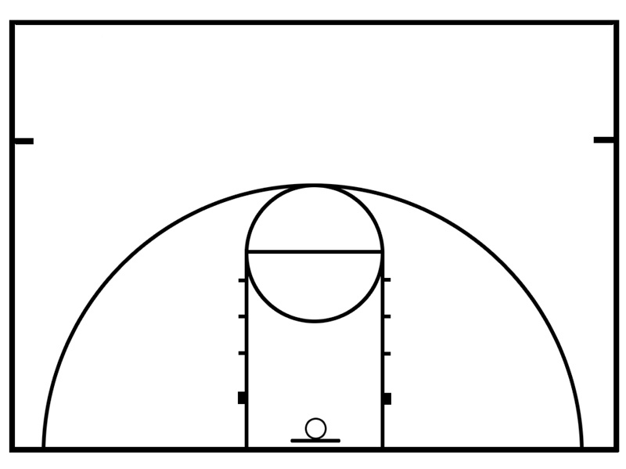
5-Out Pass Cut Replace Offense
= Pass
= Cut
= Player
= Ball

DEFENSIVE CONCEPTS
Westshore Basketball promotes the development of “player to player” defense where each player guards a player on the other team. Zone defense is not a strategy that Westshore Basketball supports and is not permitted by night league basketball rules.
Defensive concepts that players of all levels should be taught and reinforced are:
- Staying on the rope – being between your man and the hoop
- Guns up! – Seeing the ball and your player
- Head under the wire – not bouncing while sliding in defensive stance
Advanced concepts such as closeouts can be introduced at the U13 level and help defence can be introduced at U15.

Practice Part | Time | Key Elements
Introduction  Purpose is to greet athletes and let them know what will be taking place | 2-3 mins | Before Practice Begins: inspect the facility for safety issues and organize your equipment. Then greet each athlete and assess their energy levels.  At the beginning of each practice: review the goals and activities planned and give safety instructions for the planned activities.
Warmup  Purpose is to prepare the body for the efforts of the main part | 5-10 mins  8-15 mins | General: will consist of a warmup game followed by dynamic stretching.  Specific: brief activities that your athletes already know which will mimic movements of the main part. Can include a basketball.
Main Part  Purpose is to engage athletes in activities that will help them improve sport-specific abilities and fitness | 35-45 mins | 3 or more activities linked which build and develop the athletes’ skill and athleticism. The activities should:  - Challenge the athletes so they can learn and improve while enjoying themselves  - Engage the athletes most of the time during the activity (no standing around or waiting)  - Contain quality repetitions for each activity  - Be appropriate for age, fitness, and ability levels of the athletes.
Cool-Down  Purpose is to begin recovery | 5-10 mins | Consists of a gradual decrease in intensity and involves stretching.
Conclusion  Purpose is to debrief athletes and provide upcoming info | 3-5 mins | Player feedback is encouraged on what went well and suggest how improvements can be made. Information about the next practice or game will be given, a team cheer will be held, and the coach will speak with each athlete before they leave.

PLANNING A PRACTICE

U11 – FUNDAMENTALS
As a U11 coach, you will have many new players who have not experienced coaching from the Westshore Rain program, so it is essential that the proper fundamental movements are emphasized during practices. Along with the incorporation of these fundamental movement skills, your job will be to teach your athletes the basic rules and skills to play the game.

THE ABC’S OF ATHLETICISM
Because this age is an introduction to basketball for many players, proper fundamental movements to basketball such as running, jumping, lunging, and sliding must be emphasized during practice time. This can be accomplished using fun games and will give your athletes a solid foundation for when more complicated movements and skills are introduced.
The ABC’s of athleticism are:
- Agility
- Balance
- Coordination and Speed
Just like with the Westshore Rain program, these skills can be taught using fun games and during skill drills. It will be important for you as a coach to recognize when a fundamental movement should be emphasized. Obstacle courses and relays are great activities that will improve your players athleticism.

COMPETITION
Although your players will be playing in 5v5 night league games, situational drills such as 1v1, 2v2, and 3v3 are more effective in practice because this allows each player to touch and handle the ball more often than they normally would in a 5v5 scrimmage.
The focus of competition at this age should be on having fun, encouraging teamwork, and praising the effort each player exerts on the court. Winning is not a priority.

PRACTICE PLANNING
A practice plan involving your U11 athletes should include an introduction, warm up, main part, cool-down, and a conclusion. Practices should be linked which means that if you practice a certain skill such as shooting on one Sunday, then the next practice you can review that shooting skill and build on it.
A U11 practice should contain 1-2 skills per practice and have games to emphasize those skills. Traditional drills such as 3-man weave, continuous 2v1, and practicing the 5-out offense are ineffective and complicated. Instead use fun and engaging games involving spacing, movement, and teamwork that the players will enjoy learning from.
Individual challenges are a good incentive to motivate your players. How can you add individual challenges into your practice plan? A sample practice plan involving all of this will be displayed on the next page.
Todays Goals:  To show the athletes proper dribbling technique and the basic shooting form |  |  | Reminders:  Some players may not pick up on the skills as quickly as others, so wait until about 70% of the players can do the skill before moving on |  | Post practice reflection:
Time: | Part: | Activity or Drill |  | Point of Emphasis | Learning Outcomes
5pm | Intro | Practice Overview |  | Greet each athlete as they arrive, then tell the athletes as a group what you will be doing in practice | What your players will learn by the end of the practice
5:05pm | Warmup | Rock paper scissors, tag |  | This game will set the tone for practice and help shift the players focus from a previous activity (such as school) to this practice | This game will teach recognition, quick decision making, and agility
5:10pm | Main Part | Stationary Dribbling |  | Keeping your eyes up, and always having the ball in control while pounding it into the floor | The players will be able to dribble with either hand while stationary
5:20pm | Main Part | Movement Dribbling |  | Keeping eyes up and off the ball, and being able to change direction while keeping the ball in control | Players will keep their eyes up while dribbling forwards, backwards, and side to side using different speeds
5:30pm | Main Part | Dribble Robber |  | Keeping eyes up, being able to change direction to avoid the robbers, and ball protection | Recognition of when they are being defended, and being able to protect the ball from someone trying to take it
5:40pm | Main Part | FOREST Shooting |  | Players should be getting the power for their shot from their legs, and should be holding the release with shooting fingers to the floor | How to generate power to get the ball to the hoop, and how to use backspin to create a softer finish
5:50pm | Main Part | Line shooting and Rangefinder |  | Finishing with fingers to the floor, and getting the power from your shot from legs | Control over the shot is created with your arms, and the power of the shot is created with your legs
6:00pm | Main Part | 3v3 |  | Playing with each other, sharing the ball, and using cuts to get open | How to play as a team in 3v3 format
6:15pm | Cool-Down, Conclusion |  |  | Review what has been practiced, link next practice | Tell players about next practice/game time

OFFENSIVE CONCEPTS

Offensive concepts such as cutting to get open and cutting to score can be worked on during drills and will be the basic components of your team offense. Other skills such as squaring up in triple attack and attacking the hoop in a straight line should be emphasized as well.

DEFENSIVE CONCEPTS
Defense is a skill that needs to be taught just like shooting and dribbling, so for your players to improve they will need to be taught the basic defensive stance and where they should be positioned in relation to the ball, the hoop they are defending, and their check. The basic defensive skills that need to be taught are:
- Staying on the rope – on the court, your player should be situated between the hoop they are defending and their check at all times
- Guns Up! – the player should be able to see their check and the ball at all times (one finger-gun pointed at each)
- Head under the wire – your players heads should not be bobbing while they are sliding
The basics of moving while in a defensive position will need to be taught as well such as getting low and athletic, keeping your chest and hands up, and stepping with your lead foot before you push off.

LEARNING OUTCOMES
To be considered prepared to move into the next age group of Westshore Basketball, a player should know the terminology and be able to perform the following skills:
- Fundamental Movement Skills
  - Agility, Balance, and Coordination (throwing and catching)
  - Proper running technique – forwards, sideways, and backwards
  - Change of speed and direction
  - Jumping and landing
  - Starting and stopping (jump stop, stride stop)
  - Pivoting – front and reverse
- Fundamental Basketball Skills
  - With and without ball
  - Ready position
  - Offense – triple attack stance
  - Vision – play with eyes up and facing the basket
- Ball Handling
  - Ball control
  - Stationary dribbling (low, high, and wide)
  - Movement while dribbling (running, sliding, walking, change of direction, starts, stops, low, high)
- Passing Skills
  - Stationary passing – left and right hand
  - Moving passing
  - Receiving the ball – absorbing
  - Catching on the move to dribble
  - Catching the ball in triple attack
- Shooting Skills
  - Basic FOREST Shooting
  - Close range shots
  - Lay-up progression – left and right hand
- Basic Offensive Concepts
  - Advancing the ball towards your offensive basket
  - Shooting the ball into the basket to score
  - Spacing of players (ideally 3 to 4 meters apart)
  - Cutting of players (away from the ball and to the ball)
- Basic Defensive Concepts
  - Recognition of knowing when you are on defense
  - Recognition of the player he/she is defending
  - When guarding your player, making sure that you are playing “on the rope”

U13 – LEARN TO TRAIN
As a U13 coach, you will be receiving players from the U11 age group who have gone through the fundamental movement skills from prior years of Westshore Basketball, as well as new players to the game who have not experienced and trained with the basketball specific movements. This means that continued training and refinement of the fundamental movement skills introduced by the Westshore Rain and U11 programs is critical to the development of your athletes.

THE ABC’S OF ATHLETICISM
Assessment of your players fundamental movements will give you an idea of what types of athletes you are going to be working with. It is important to not introduce advanced movements into drills when your athletes are not prepared for them as it increases the risk of injury. The training of these fundamental movements can take place during the General warmup (which can be a Dynamic warmup) and during the Specific warmup (which will teach and reinforce the movements the athletes will be doing in upcoming drills).
An example of a specific warmup would be doing full court defensive slides while passing a basketball to a partner, which would challenge their passing and warm up the muscles the players would be using if you had defensive slides planned in your practice.

Sample Dynamic Warmup:
A way to load (challenge) your athletes during their dynamic warmup would be to pass them the ball while they are doing the dynamic, or getting them to dribble at the same time
High Knees
Butt Kicks
High Knees Butt Kicks
Skips to Sprint (forwards, backwards, sideways)
2-foot bounds (forwards, backwards, sideways)
1-foot bounds (forwards, backwards, sideways)
Lunges
Alternating Lunge Jumps
Quick feet sprints (forwards, backwards, sideways)
Partner sprints

COMPETITION
Although your players will be playing in 5v5 night league games, situational drills such as 1v1, 2v2, and 3v3 are more effective in practice because this allows each player to touch and handle the ball more often than they normally would in a 5v5 scrimmage.
It is your job as a coach to assess your players competition level and plan accordingly. While some players join basketball for the social and recreational aspect of the game, the spirit of competition will keep them returning year after year if they embrace the challenge.

PRACTICE PLANNING
A practice plan involving your U13 athletes should include an introduction, warm up, main part, cool-down, and a conclusion. Practices should be linked which means that if you practice a certain skill such as shooting on one Sunday, then the next practice you can review that shooting skill and build on it. Strategies such as the 5-out offense should be practiced every practice on top of skills.
Fun games can be used to emphasize the skills practiced and give the players drills to look forward to in future practices. Individual and team challenges can be used to motivate the team during drills, for example, setting a team goal during a team shooting drill or individual challenges when they are not as team focused.
Todays Goals:  To work on the teams shooting form and 1v1 fundamentals |  |  | Reminders:  Some players may not pick up on the skills as quickly as others, so wait until about 70% of the players can do the skill before moving on |  | Post practice reflection:
Time: | Part: | Activity or Drill |  | Point of Emphasis | Learning Outcomes
5pm | Intro | Practice Overview |  | Greet each athlete as they arrive, then tell the athletes as a group what you will be doing in practice | What your players will learn by the end of the practice
5:05pm | Warmup | Game: British Bulldogs |  | This game will set the tone for practice and help shift the players focus from a previous activity (such as school) to this practice | This game will teach dribbling awareness, offensive and defensive strategy, and dribbling security
5:10pm | Warmup | Dynamic |  | Teaching and reinforcing fundamental movement skills | Increased movement ability
5:15pm | Main Part | FOREST Shooting |  | The power for the shot comes from the legs, and the release should be held | How to generate power to get the ball higher, and how to create backspin
5:20pm | Main Part | Release Progression I, II, III, and IV |  | Loading up, locking the elbow, flicking the wrist, and holding the release | How different parts of your body work together to create a shot
5:30pm | Main Part | Kiwi Shooting |  | Squaring up to the hoop and shooting in rhythm | How different levels of power from the legs allows you to shoot farther
5:40pm | Main Part | Jab steps and pump fakes |  | Jabs and pump fakes should be short and quick | How do jab steps and pump fakes affect the defense?
5:50pm | Main Part | 1v1 |  | Use all the jabs, fakes, and shooting techniques taught | Which fakes work the best for me? Which ones do I need to work on?
6:00pm | Cool-Down | Introduction to 5-out offense |  | Show the 5 spots that need to be filled and how to move within those spots | A basic understanding of the offense should be known
6:15pm | Conclusion |  |  | Review what has been practiced, link next practice | Tell players about next practice/game time

OFFENSIVE CONCEPTS
At the U13 level players should be learning to play within the 5-out offensive system, where scoring looks are created from off ball movement and individual offense. Playing within the 5-out offense gives the players the freedom to discover what they are capable of and gives organization to the team.
Patience is required when teaching the 5-out offense, and mastering hoop cuts (pass, cut to the hoop, and replace) is recommended before adding off-ball screens into the offense.
A simple way to initiate the 5-out offense is with a “quick hitter” play to get your players organized and into position. You may have to designate positions for your players to make their job on the court easier.
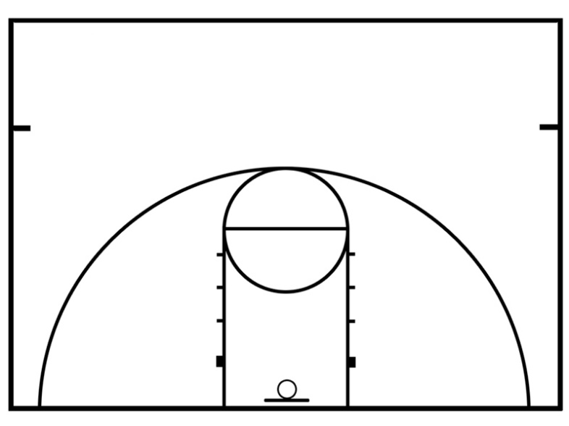
Quick Hitter:
In this quick hitter the players without the ball must sprint to fill the 5 spots and set 2 down screens as the ball handler passes half court.

DEFENSIVE CONCEPTS
On top of knowing the 3 concepts of “Staying on the rope”, “guns up”, and “head under the wire”, players can now be introduced to closeouts. Closeouts are when a defensive player is required to close space between their check and themselves to prevent a shot. Closeouts must be executed under control and on balance.
Teaching Closeouts: (video tutorial)

LEARNING OUTCOMES

To be considered prepared to move into the next age group of Westshore Basketball, a player should know the terminology and be able to perform the following skills:
- Fundamental Movement Skills
  - Development and refinement of the ABC’s of Athleticism
- Fundamental Basketball Skills
  - Triple Attack
  - Holding/ripping the ball
  - Footwork – pivoting (front and reverse) using either foot
  - Movement with the ball – jump stops, stride stops
  - Starting – being able to push off effectively with both feet
- Dribbling
  - Stationary dribbling with left and right hand
  - Dribbling while moving with left and right hand in all directions
  - Speed dribble, control dribble, change of direction dribble with either hand
  - Vision – handling the ball while scanning the floor
- Passing and Catching
  - Introduction or refinement of the basic stationary passes (chest, bounce, overhead, baseball)
  - Passing and catching on the move
  - Passing and catching against an opponent
- Shooting
  - FOREST Shooting refinement
  - Introduce or refine technique for lay-ups from both sides
- Developing One-on-One Skills
  - Triple Attack stance, squaring up to the basket
  - Reading the defence
  - Ball fakes and foot fakes (small and quick)
- Getting Open
  - Moving to get open
  - Coming to the pass
  - Pivot to be an offensive threat
- Defensive Stance on the Ball
  - Introduce Stance
  - Moving in your defensive stance while “on the rope and being assertive
- Defensive Stance Away from Ball
  - Staying “on the rope” and having “guns up”
  - Helping your teammates
  - Recovering to the player your guarding with a closeout
- Offensive Concepts
  - Playing with the purpose of scoring
  - Playing 1v1
  - Spacing within the offense
  - Give and go
  - Cut and replace/fill
  - Read the defence to attack and score
- Defensive Concepts
- Playing in stance and communicating at all times
- Sprinting back on defence
- Playing “on the rope” and with “guns up”

U15 – TRAIN TO TRAIN
As a U15 coach, you are tasked with preparing your athletes for high-school basketball. Although not all the athletes on your team will play at the next level, Westshore Basketball strives for 0% dropout rates and continued participation in organized basketball. This can be achieved with positivity, encouragement, and the focus on growth from the coaches.

THE ABC’S OF ATHLETICISM
Now that most of the athletes have advanced through the previous stages in Westshore Basketball, they should have a grasp of what a dynamic warmup is and be able to execute basic fundamental movements competently.
If you feel your players are ready, the following dynamic warmup can have progressions added to it such as receiving and passing a ball, 1 ball dribbling, and 2 ball dribbling.
High Knees
Butt Kicks
High Knees Butt Kicks
Skips to Sprint (forwards, backwards, sideways)
2-foot bounds (forwards, backwards, sideways)
1-foot bounds (forwards, backwards, sideways)
Lunges
Alternating Lunge Jumps
Quick feet sprints (forwards, backwards, sideways)
Partner sprints

To ensure the safety of your athletes, assess their athletic abilities before challenging them with more difficult movements or adding a basketball.

COMPETITION
Although your players will be playing in 5v5 night league games, situational drills such as 1v1, 2v2, and 3v3 are more effective in practice because this allows each player to touch and handle the ball more often than they normally would in a 5v5 scrimmage.
It is your job as a coach to assess your players competition level and plan accordingly. While some players join basketball for the social and recreational aspect of the game, the spirit of competition will keep them returning year after year if they embrace the challenge.

PRACTICE PLANNING
A practice plan involving your U15 athletes should include an introduction, warm up, main part, cool-down, and a conclusion. Practices should be linked which means that if you practice a certain skill such as shooting on one Sunday, then the next practice you can review that shooting skill and build on it. Strategies such as the 5-out offense should be practiced every practice on top of skills.
During your practice, team and individual challenges are a good way to keep you athletes motivated. A consequence for not completing the challenge can be added to increase the pressure and keep it interesting. A sample practice plan containing all of this will be on the next page.
Todays Goals:  To work on defensive closeouts and how to attack the closeout |  |  | Reminders:  Keep the drills competitive by adding a goal to achieve |  | Post practice reflection:
Time: | Part: | Activity or Drill |  | Point of Emphasis | Learning Outcomes
5pm | Intro | Practice Overview |  | Greet each athlete as they arrive, then tell the athletes as a group what you will be doing in practice | What your players will learn by the end of the practice
5:05pm | Warmup | Game: Dribble Knockout |  | This game will set the tone for practice and work on the athletes keeping their heads up while dribbling | Using changes of speed, direction, dribbling hand, and stance to protect the ball. Also, how to use your off-hand.
5:10pm | Warmup | Dynamic |  | Teaching and reinforcing fundamental movement skills | Increased movement ability  Can add dribbling for challenge
5:15pm | Main Part | Closeout Instruction |  | Being assertive on the closeout and taking away the shot first | When and how to use the closeout during defense
5:20pm | Main Part | Coach Closeouts |  | 3 hard slides to the corner | How to force the offense to the corner, no middle penetration
5:30pm | Main Part | 1v1 Closeouts |  | No middle penetration for the offense, move your feet | How much effort it takes to stop someone using a closeout, and how easy it is to attack the closeout
5:40pm | Main Part | 5-Out Pass, Cut, Replace |  | Cut to the hoop after making a pass | How to move the ball and have off-ball movement during 5-out
5:45pm | Main Part | 5-Out Pass, Screen Away, Replace |  | Set an off-ball screen after making a pass | I can get my teammates open by setting an away screen in the offense
5:50:pm | Main Part | 3v3 King of the Court |  | Use cutting and screening away to get open, and put yourself at an advantage offensively by creating situations to attack the closeout | How to create openings to score for you and your teammates
6:05pm | Cool-Down | 5-out pass cut replace review |  | Discuss with your teammates what worked for you in the 3v3 and what didn’t | Players will communicate with each other how to work together and how to play within the offense
6:15pm | Conclusion |  |  | Review what has been practiced, link next practice | Tell players about next practice/game time

OFFENSIVE CONCEPTS
At the U15 level players should know how to play within the 5-out offensive system, such as how to get their teammates and themselves open. Showing your players how to make effective off-ball cuts may be needed, as well as how to set off-ball screens. Playing within the 5-out offense gives the players the freedom to discover what they are capable of and gives organization to the team.
Setting ball screens can be introduced at the U15 age, and it is important that everyone knows how to run off the ball screen and how to set the ball screen. Do not designate certain players on your team (such as the tallest player) to be the only ball screener because that is all they will end up doing on offense. Only introduce ball screens if your players are capable of running them.
A simple way to initiate the 5-out offense is with a “quick hitter” play to get your players organized and into position. You may have to designate positions for your players to make their job on the court easier. Two quick hitter plays will be shown on the next page, either of which can be run every time down the court (unless your team is on a fast break). To relieve pressure on the ball handler carrying the ball up the court, have the quick hitter down screens run once the ball handler crosses half court. You may need to practice how to dribble while under pressure to run these.
Quick Hitter 1: Double down screens
In this quick hitter the players without the ball must sprint to fill the 5 spots and set 2 down screens as the ball handler passes half court.
Quick Hitter 2: Down screen to ball screen
In this quick hitter the players will do the same double down screens as in Quick Hitter 1, but now the corner player will sprint off the down screen to set a ball screen. Try to set up the ball screen so the ball handler is going off it with his strong hand.

DEFENSIVE CONCEPTS
a
On top of knowing the 4 concepts of “Staying on the rope”, “guns up”, “head under the wire”, and closeouts, players can now be introduced to help defense.
When teaching help defense do not be picky on where the help comes from, focus on the awareness and communication involved in help defense. There are 3 things that must be done in help defense:
- The defender who got beat must communicate with their team that they need help by yelling “Help! Help! Help!”
- Someone must leave their check and step up to the offensive player to ensure that a layup is not scored and communicate that they have help by yelling “I’ve got your help!” or “I got hoop!”
- A third player must “help the helper” which is done by covering for the player who helped their teammate in step two.
Success on defense is done mainly by communication and intensity. Do not get upset with your players getting beat but encourage them to assert themselves on defense and not worry about getting beat because they have teammates who will step up to help them when it does happen (and it will happen – all the time).

LEARNING OUTCOMES
a
To be considered prepared to move into the next age group of Westshore Basketball, a player should know the terminology and be able to perform the following skills:
- Fundamental Movement Skills
  - Refine ABC’s of Athleticism
- Fundamental Basketball Skills
  - Refine footwork – pivoting (front and reverse) and using either foot
  - Early decision making before the catch of the ball
  - Refine movements with ball – jump stops, stride stops
  - Ball handling – becoming comfortable with the ball, ball protection, vision, handling ball under pressure
- Dribbling/Ball Handling
  - Expand the dribble move repertoire
  - Refine and develop speed, control, change of direction, retreat, and change of pace
  - Refine and develop the concept of dribbling against a guided defender
  - Making proper reads and reactions
  - Refine ability to handle the ball while scanning the floor
- Passing and Catching
  - Expand the passing repertoire – add variations to the basic passes
  - Increasing the speed at which the ball can be passed and caught
  - Develop ball and pass faking concepts
  - Making proper reads and reactions
- Shooting
  - Review and refine the FOREST Shooting
  - Execution of the “perfect” form shooting
  - Develop shot-ready techniques – catch and shoot from a pass in a variety of directions
  - Develop catch and shoot off a dribble in a variety of directions
  - Review and refine lay-up repertoire (ex. Baby hook, reverse, right and left hand, power, euro-step)
  - Develop a free throw shooting routine
  - Shooting and lay-ups with guided defender and making proper reads
  - Expand shooting repertoire – off dribble, off catch, different angles, different speed, range
- Getting Open
  - Using change of direction, change of pace, sealing and a teammate
  - Read and react to guided defence
  - Move to the pass
  - Get open in a variety of positions (wing, low block, elbow, top, baseline)
- Developing One-on-One Skills
  - Squaring to the hoop assertively to be a scoring threat
  - Develop a one-on-one repertoire (off dribble, jab fakes, shot fakes, combos)
  - Read and react to guided defence
  - Play from a variety of positions
- Multi-Player Manoeuvres
  - Develop and refine
  - Pass and catch
  - Penetration principles (attacking the hoop and passing to open player)
  - Ball screen
  - Screen away from the ball
  - Playing without the ball
  - Emphasize ball movement
  - Read and react to guided defence
- Transition Offence
  - Develop the concept of lanes and outlets
  - Recognize advantages while attacking the basket
  - Read and react to guided defence
  - Emphasize all players playing all positions
  - Emphasize ball movement
- Defence
  - Introduce the concept of help defence
- Defence on the Ball
  - Refine defensive stance against an offensive player with emphasis on ball pressure
  - Develop and refine maintaining the gap and change of direction against a ball handler with emphasis on ball pressure
  - Introduce the concept of contesting a shot, pass, and dead ball
- Defence off the Ball
  - Refine and develop stance
  - Introduce and develop denial of the pass
  - Introduce and develop help, rotate, and recovery
  - Introduce and develop defending off-ball screens
  - Moving from one defensive stance to another (ball stance to help stance, help stance to denial stance)
- Rebounding
  - Introduce and develop boxing out
  - Introduce and develop the skills of offensive rebounding
- Transition Defence
  - Defend the basket, ball, and lanes in transition
  - Sprinting to recovery
  - Emphasis on communication when picking up checks
- Offensive Concepts
  - Reading and reacting to the defence
  - Playing one-on-one
  - Penetration principles – using the dribble and passing wisely, movement without the ball
  - Spacing of 3 to 4 meters
  - Cutting – basket cuts, ball cuts, and spacing cuts (filling/replacing)
  - Introduce and develop ball screens
  - Emphasize ball and player movement
  - Rebounding offensively
  - Communication with teammates
- Defensive Concepts
  - On the ball – staying in stance, “on the rope”, maintaining the gap, ball pressure, and defending screens
  - Off the ball – staying “on the rope” with “guns up”, defending screens (use the switch)
  - All players have a responsibility in team defence
  - Challenging all shots
  - Rebounding and boxing out
  - Emphasis on communication with teammates

References
Canadian Basketball LTAD Model - LTAD.pdf
Windows of Trainability - bayliltad_2004.pdf

Additional Coaching Resources
Canada Basketball Coaches Toolbox - Toolbox.pdf
Toronto Raptors Shooting - Shooting.pdf
FOREST Shooting –
Breakthrough BBall - http://www.breakthroughbasketball.com

